Student’s Name

Professor’s Name

Course

Date

How did Mexicans Immigrants Affect the U.S. Agriculture Industry?

**Introduction**

Immigration has been a significant aspect of the agriculture industry in the United States because immigrants offer a source of cheap labor for farms. In the mid-twentieth century, the U.S. labor force continued its move from farm-work, farmers in the country then focused on Mexican immigrants to offer additional labor for their farms. Mexican immigrants were able to enter the United States through legal channels such as the Bracero Program (between 1942 and 1964), H-2 Visa Program (between 1953 and 1985), and H-2A Temporary Agricultural Program (since 1986 to date). Other immigrants entered the U.S. through illegal means. The availability of Mexican immigrants has offered a source of cheap labor for labor-intensive selectors such as the production of line or horticulture. Immigrants are critical to the development of agriculture and have contributed to making the U.S. agriculture industry one the largest in the world. Mexican immigrants helped to improve the agriculture industry within the United States by offering a cheap source of labor.

**Research Questions**

Some of the main questions that the study will look to answer include: why were Mexican immigrants motivated to move to the United States? Why was the agriculture industry ideal for Mexican immigrants? Why did American farmers prefer Mexican laborers to American workers? How did the Mexican immigrants impact the agriculture industry within the United States? And what is the current state of Mexican immigration in the U.S., and how has this affected agriculture?

**How Will the Research Questions Fit the Literature Review?**

These research questions will help to prove the hypothesis of the research i.e., Mexican immigrants helped to improve the agriculture industry within the United States by offering a cheap source of labor. The first questions offer an elucidation on the economic conditions in the U.S. and Mexico and how these conditions encouraged Mexican immigrants in rural settings in Mexico to go to the U.S. in search of better opportunities. The second question looks at the prospects in the agriculture industry and how these prospects enticed Mexican immigrants. The third question explains why Mexican immigrants were preferred in the agriculture industry to American laborer. The fourth question explores the overall impact of the Mexican migrants on the U.S. agriculture industry. The final question shows the current impact of Mexican laborers and the agriculture sector.

**Research Methodology**

The paper will focus on qualitative research as its main design to prove the hypothesis of the study. This research design is ideal for the study because of its multi-method focus, which focuses on an interpretive and naturalistic strategy on the subject matter (McLeaod). The researcher will use the research design to attempt to explain the impact of Mexican immigrants on the agriculture sectors within the United States. Qualitative research helps to explain 'why' and 'how' a particular phenomenon occurs within a specific context. This is in line with the aim of this study. The researcher will use the different tools within the research methodology in order to explain the impact of Mexican immigrants on the agriculture industry in the U.S. The study will use the literature review as the main data collection technique. The scope of the research will be limited and will collect data on the role and impact of Mexican immigrants in the agriculture industry within the United States between 1970 and 2010. The literature review will also look at the current situation about Mexican immigration and its potential impact on agriculture in the country. The researcher will use document analysis as the main technique for analyzing the data collected through the literature review.

**Data Description (Literature Review)**

The agriculture industry within the United States has been central to the country's economy. The United States agriculture sector spreads beyond the farming enterprise and stretches beyond the scope of farm-related sectors. The largest sector in agriculture is food manufacturing and foodservice. According to the U.S. Department of Agriculture Economic Research Service, the country's expenditure on food is approximately 13% of household budgets (U.S. Department of Agriculture Economic Research Service). Research indicates that agriculture plays a significant role in the development of the United States economy. Agriculture contributes to the U.S. economy by offering raw materials for industries, food, and monetary surplus (which include foreign exchange) in order to invest is critical for the process of development (Van Arendonk 2). American ranchers and farmers make an important contribution to the economies of rural areas and small towns, where agriculture supports different sectors such as food processing companies and machinery manufacturers. The agriculture sector has been vital because it has helped to support millions of jobs in the country. Projections from the U.S. Department of Agriculture model, developed between 2010 and 2011, indicate that for every one billion dollars in agricultural exports, there will be approximately one million jobs (Joint Economic Committee 2). Therefore, the agriculture sector has been critical to the economic development of the country.

United States agriculture is one of the largest agricultural competitors within the global market because of its sound infrastructure, market size, and the large workforce. The Western United States agriculture sector is an industry which has been shaped and is shaped by unique labor regulation: seasonal laborers are foreigners who are looking to jobs in the agriculture sector, there are no permanent jobs (Martin 1124). Foreigners were ideal for seasonal work within the agriculture sector because they do not plan to stay farm laborers forever, and local farmers did not see them as long term migrants. The integration and immigration policy, in effect, focused on recruiting new laborers who were willing to take part in seasonal employment, and also to avoid their assimilation in agricultural sectors. As such, for many immigration laborers, economic mobility requires geographic mobility. The country has approximately 2 million farms. In 2000 alone, farmers in the country had cash receipts for sales of fiber and food of approximately 223 billion dollars (Martin 1124). Approximately 25% of the United States was exported, and this has helped to continue the nation's agricultural trade surplus. Its peculiar labor policy has shaped the agriculture sector in the U.S., and this has underwritten to its tremendous success on a global scale.

Immigration has been at the center of the United States agriculture industry. In the mid-twentieth century, as the United States labor force continued its long-run switch from farm-work, United States growers focused on Mexico to offer additional labor for their farms. During the latter part of the twentieth century, laborers went into the U.S. to work at comparatively low wages. Some immigrants were able to enter the United States as guests via the Bracero Program (between 1942 and 1964), H-2 Visa Program (between 1953 and 1985), others immigrants have crossed the U.S., through unauthorized or authorized immigration, while others utilized the H-2A Temporary Agricultural Program (since 1986 to date) (Zahniser et al. 1). The ability of American farmers to attain cheap labor from Mexican immigrants enabled them to the production of labor-intensive crops such as vegetables, fruits among other horticultural products, to grow regardless of the low availability of U.S. born workers to produce these agricultural products. Additionally, the large supply of labor at a relatively low cost discouraged investment and research in labor-saving agricultural technologies (Zahniser et al. 1). The influx of Mexican immigrants in the U.S. agriculture industry created challenges for unions who were looking to organize farm laborers, who had little bargaining power since most immigrants were willing to work under the current conditions. Therefore, it is evident that Mexican migrants had a significant impact on the United States agriculture sector.

The U.S. agriculture industry is a diverse sector that has been supported by labor from immigrants. Labor's significance to the United States agriculture differs by sector, with some subdivisions being labor-intensive while others remain capital-intensive. Findings from an Agricultural census conducted in 2012 revealed that hired and contract labor accounted for approximately 10% of the country's total operating costs (*See Table 1*). However, for some sectors of agriculture, this share was bigger, for example, it was 39% for tree nut and fruit farming, 40% for floriculture, greenhouse, and nursery production, and 27% for melon and vegetable farming (Zahniser et al. 4). Laborers who were hired indirectly via farm labor contractors made up approximately 19% of United States agriculture's overall labor expenses i.e., both hired labor and contract labor. Mexican immigrants have played a significant role in the agriculture of Lower Rio Grande Valley in Southern Texas (Stoddard). Mexican immigrants have been heavily involved in the production of lime. Aside from this, Mexican immigrants have also been heavily involved in the production of watermelons in Colorado and Oklahoma. Federal surveys indicate that there are approximately 7000,000 to 850,000 hired farm laborers, on average, at any particular point in the country (Stoddard). Research indicates that approximately 75% of the hired labor in American farms are Mexican immigrants. This demonstrates the significance Mexican immigrants have had on the U.S. agriculture industry.

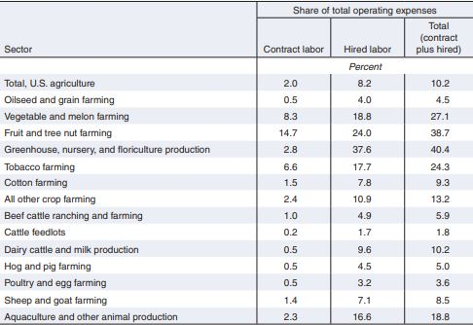

Figure 1: Labor's share of the United States agriculture's operating expenses which differs in the different sectors

Source: Zahniser, Steven, et al. Farm labor markets in the United States and Mexico Pose challenges for U.S. agriculture.

Many large scale farmers in the United States, especially those with the operation, have a big share of their expenditures dedicated to labor, depend on alien laborers. A research conducted by the United States Department of Labor's National Agricultural Workers Survey approximately 75% of hired laborers in crop production were born out of the United States. From this statistic, approximately 50% of hired laborers within the United States are lacked the federal immigration status required to work legally within the United States (Zahniser et al. 5). The number of foreign-born laborers and illegal workers working in the United States agriculture industry have made the nation's farm labor market vulnerable to a number of factors. Some of these factors include economic and demographic conditions within the U.S. and the laborers' native countries, immigration flow, the structure of the labor force with respect to their migration status, and the enforcement of immigration law. A research conducted in order to determine the time allocation of farmworkers in crop agriculture between 1992 and 2012, it was observed that flexible employment opportunities offered a decreased interest in agriculture (Zahniser et al. 5). When the research compared undocumented workers and Green Card holders, it was observed that illegal laborers tended to dedicate the greatest share of their workweeks to farm labor. On the other hand, Green Card holding laborers tended to dedicate the lowest share. Findings from the study also revealed that undocumented laborers were less likely to that documented laborers to decrease their size of agricultural work when the conditions of the non-farm economy developed (Zahniser et al. 5). As such, immigration into the United States has been critical to the success of the agriculture industry.

Immigrants in the United States have helped to improve the crucial sector of the country's economy, such as the agriculture industry. This is because they offer skilled and semi-skilled labor at cheaper rates. However, The United States has experienced a rapid decrease in the number of illegal migrants. The decline in the number of immigrants in the country is attributed to a sharp drop in the number of Mexicans entering the U.S. without sanction. There are approximately 10.7 million immigrants in the country, and this is a sharp decline from the 12.7 million migrants back in 2007 (Pew Research). From this, the number of illegal Mexicans in the United States was approximately 50%. The illustration below demonstrates the prevalence of Mexicans within the United States over the past decades (Figure 2). Regardless of their decreasing number, unauthorized immigrants in the U.S. still play a critical role in the country’s agricultural sector. The Department of Agriculture found that about 50% of the country's undocumented farm laborers are illegal migrants. Research demonstrates that the presence of immigrants in the country has been central to the development of critical sectors such as agriculture. Therefore the existence of immigrants has helped to grow the United States economy and have led to the growth and establishment of the U.S. agriculture industry on a global scale.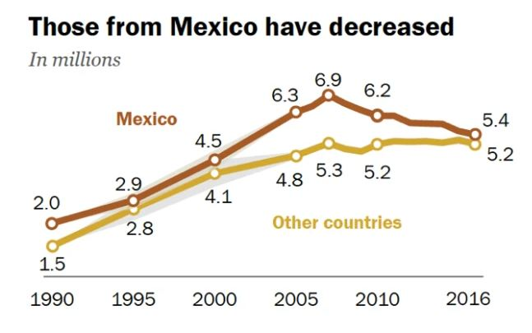

Figure 2: Mexican immigrants in the U.S over the past two decades.

Source Pew Research Center. 2018. Available at https://www.pewresearch.org/hispanic/2018/11/27/u-s-unauthorized-immigrant-total-dips-to-lowest-level-in-a-decade/ph_2018-11-27_unauthorized-immigration-estimate_0-01-2/

Mexican migrants have had a significant influence on the cost of labor within the agriculture industry. Mexican immigrants tend to earn less income than non-Hispanic whites and native Mexican Americans. A change in the political economy and the drop in the quality of consecutive associates of Mexican immigrants has upsurge the number of people who lack full labor rights within the United States. Consequently, it has resulted in increased exclusion and discrimination against this demographic (Massey and Julia 328). Between the 1980s and 1990s, Mexican immigrants experienced problems in their economic standing within the country. There was a shift in economic fortunes in the United States, which is best demonstrated in *Figure 3*. This illustration shows the trend in wages, which was netted by native-born, non-Hispanic whites, foreign-born Mexicans, and native-born. Between 1950 and 1970, there was a steady rise in wages. Despite this fact, native whites earned more than Mexican Americans who, in turn, earned more than Mexican immigrants (Massey and Julia 328). The monetary fortunes of all three groups enhanced throughout the post-war economic boom, where wages rose at about the same speed across different groups. Mexican migrants are willing to work for less than the other demographics in the labor market, this has made them ideal for the agriculture industry.

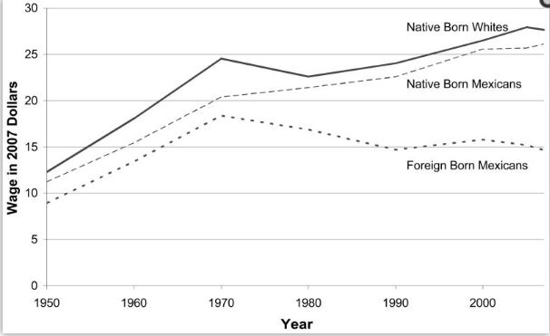

Figure 3: trends in hourly wages among the three demographics.

Source Massey, Douglas S., and Julia Gelatt. "What happened to the wages of Mexican immigrants? Trends and interpretations." Latino Studies 8.3 (2010).

With firmer immigration policies, the immigration of casual laborers from Mexico to the United States has been steadily declining, and this has affected its impact on the agriculture industry. As the country continues to grapple with the result of failed efforts to fix immigration policy and establish an immigrant laborer program, one thing remains clear; the United States agriculture industry is mostly dependent on immigrant labor (Stoddard). However, current trends indicate that the availability of Mexican immigrants who work on farms is slowly diminishing. Currently, the United States agricultural heads find it hard to offset the diminishing supply of farm labor from their main source i.e. Mexico with more laborers from other nations. Some of the reasons that have underwritten this decrease include, the United States is now forced to compete with other nations such as Mexico which are also expanding their agricultural production, rising educational levels in rural setting in Mexico have empowered farm laborers to pursue other prospects outside of agriculture, the growing service economy has also offered laborers with prospects outside agriculture (Zahniser et al. 2). The decreasing availability in the number of Mexican immigrants to work in the agriculture industry has meant that most farmers have to look for labor in other distant nations, which has increased the cost of labor (Zahniser et al. 2). The influx of Mexican migrants into the United States is slowly on their decline, and this has affected their impact on the agriculture industry.

**Data Analysis**

The researcher employed document analysis to interpret the data defined in the literature review and give voice and meaning surrounding the study topic. Throughout the literature review, it is evident that Mexican immigrants have played a critical role in shaping the agriculture industry within the United States. The contribution of Mexican immigrants in the U.S. agriculture sector has made it one of the largest sectors in the nation's economy, taking up approximately 13 percent of the household budgets (U.S. Department of Agriculture Economic Research Service). The agricultural industry in the U.S. was particularly appealing to Mexican immigrants because of its peculiar labor policy. The industry is seasonal, and this encouraged foreign laborers to exploit the vast labor shortage in the sector because American laborers were transitioning to more lucrative prospects. Foreign-laborers were also idea for farmers because they were viewed as a cheap source of labor for their farms. Mexican immigrants were able to gain authorized entry into the U.S. through programs such as the Bracero Program (between 1942 and 1964), H-2 Visa Program (between 1953 and 1985), and H-2A Temporary Agricultural Program (since 1986 to date) (Zahniser et al. 1). There is also a vast number of Mexican migrants who entered the United States illegally. The Mexican immigrants were able to improve the agriculture industry by bringing skilled and semi-skilled labor into different subsections of the agriculture industry at a low price, as illustrated by *figure 4*. Mexican immigrants in the U.S. earn significantly less than non-Hispanic whites and native Mexican Americans. However, with economic developments in Mexico and other nations, Mexicans' influx into the U.S. is on the decline. As such most Mexicans from rural settings have diverged from agriculture into different sectors, and this has negatively affected the source of cheap labor for farmers in the U.S. This has meant that U.S. farmers must look to other nations to get the labor for their farms.

Figure 4: Share of Operating Cost within the Agriculture Sector

**Discussion of Results**

Mexican immigrants have been critical to the development of the agriculture industry within the United States. Mexican immigrants were preferred to other immigrants because of their availability in Mexico. Most immigrants from Mexico came to the U.S., through both legal and illegal means, in a bid to find better opportunities for themselves. Aside from this, the U.S. farmers knew that Mexican laborers would offer a cheap source of labor while still offering skilled and semi-skilled labor. The availability of labor at a cheap price has helped the agriculture industry to develop sound infrastructure and market size, which makes the sector one of the largest agricultural competitors within the global market. The presence of Mexican immigrants has helped to improve farm yields that have resulted in agricultural trade surplus at a national level. Also, the ability of immigrants to work within different areas within the agriculture sector has been crucial in the development and growth of the industry. However, economies growth and development in Mexico and rising educational levels within the country has offered citizens with alternative means to generate sources of income. As a consequence, fewer Mexican immigrants are moving into the U.S. to look for jobs within the agriculture industry. The study consequently recommends for the U.S. to invest in agricultural-based technologies that will improve crop and livestock production and reduce reliance on employment management strategies and manual labor requirements, which will help to improve the productivity of the agriculture industry.

**Conclusion**

Immigration has been key to the success and development of the agriculture sector within the United States. The agriculture industry has emerged as one of the largest sectors in the nation's economy, contributing to approximately 13 percent of the nation's household income. During the mid-20th century, Native Americans shifted from labor jobs within the agriculture sector into more lucrative prospects, and this created an excellent demand for casual labor within the industry. Most farmers shifted their focus to Mexico because it offered them a source of cheap labor. Mexican immigrants were able to enter into the United States through legal channels such as the Bracero Program (between 1942 and 1964), H-2 Visa Program (between 1953 and 1985), and H-2A Temporary Agricultural Program (since 1986 to date). Other Mexican immigrants entered the nation illegally. Mexican immigrants were the main source of causal labor in the different subdivisions in the industry, and this contributed to the growth of the sector. However, with economic development in Mexico and rising educational levels, many Mexican immigrants are looking for new opportunities away from agriculture. Therefore, most farmers are now struggling to get the labor for their farms. To address this issue, the research recommends for the industry to shift its focus from employment management strategies and manual labor requirements and focus on agricultural-based technologies that will improve crop and livestock production.

Works Cited

Joint Economic Committee. The Economic Contribution of America’s Farmers and the Importance of Agricultural Exports. 2013. Available at https://www.jec.senate.gov/public/_cache/files/266a0bf3-5142-4545-b806-ef9fd78b9c2f/jec-agriculture-report.pdf

Martin, P. "Mexican workers and U.S. agriculture: The revolving door." International Migration Review 36.4 (2002): 1124-1142.

Massey, D., and Julia G. "What happened to the wages of Mexican immigrants? Trends and interpretations." Latino Studies 8.3 (2010): 328-354.

McLeod, S. What’s the difference between qualitative and quantitative research? 2019. Available at https://www.simplypsychology.org/qualitative-quantitative.html

Pew Research Center. 2018. Available at https://www.pewresearch.org/hispanic/2018/11/27/u-s-unauthorized-immigrant-total-dips-to-lowest-level-in-a-decade/ph_2018-11-27_unauthorized-immigration-estimate_0-01-2/

Stoddard, E. Agriculture dependent on migrant workers. Reuters. 2007. Available at https://www.reuters.com/article/us-usa-immigration-farms/agriculture-dependent-on-migrant-workers-idUSN1526113420070723

U.S. Department of Agriculture Economic Research Service. Ag and Food Sectors and the Economy. 2019. Available at https://www.ers.usda.gov/data-products/ag-and-food-statistics-charting-the-essentials/ag-and-food-sectors-and-the-economy/

Van Arendonk, A. The Development of the Share of Agriculture in GDP and Employment. Diss. Master’s Thesis, Wageningen University, Wageningen, the Netherlands, 2015.

Zahniser, S., Taylor, E., Hertz, T., and Charlton, D. Farm labor markets in the United States and Mexico Pose challenges for U.S. agriculture. No. 1476-2018-8188. 2018.